FINAL PROJECT

CM 3070

FINAL REPORT

Table of Contents

Abstract 5
Chapter 1 6
Introduction 6
Chapter 2 8
Literature Review 8
2.1 Automated Essay Scoring (AES) Systems 9
2.1.1 Transformers 10
2.1.2 Optical Character Recognition (OCR) 11
2.1.3 Automated Speech Recognition (ASR), Speech-To-Text (STT) 13
2.1.4 Multimodal Systems 15
2.2 Challenges and consideration for component selection 17
Evaluation Metrics 21
Chapter 3 23
Design 23
3.1 System Architecture 24
3.2 System Workflow 26
3.3 Component Selection 29
3.4 User Interface Design 30
3.5 Scope 32
3.6 Data/ System Design 33
Chapter 4 35
Implementation 35
4.1 Implementation Environment 36
4.2 Data Processing and Management 37
4.3 OCR Implementation 38
4.5 ASR Implementation 38
4.6 AES/Transformer Implementation 39
4.6 Evaluation/Routing Logic 40
4.7 System Integration 41
Code Design 41
Procedure 41
System Deployment/Implementation Details 43
CHAPTER 5 44
Evaluation 44
5.1 Evaluation Methodology 45
5.2 Unit Testing 46
5.3 OCR Evaluation 47
5.4 ASR Evaluation 48
5.5 Transformer/AES Evaluation 49
5.6 Integration/System Evaluation 50
5.7 End-User/Usability Evaluation 51
5.8 Overall Evaluation 52
5.2 Unit Tests 54
5.3 Component Testing 57
Chapter 6 65
Conclusion 65
6.1 Conclusion 66
6.2 Future improvements: 67
Reference List 68
Appendix A – Testing Documentation 72
B.1 Unit Tests 73
B.2 OCR Component Tests 75
B.3 ASR Component Tests 76
B.4 Transformer Component Tests 78
B.5 Integration Tests 79
B.6 Functional System Tests 80
B.7 End-User Tests 82
B.8 USABILITY TESTING 83

Abstract

Artificial intelligence technology is becoming increasingly integral to education, driven by the shift to online learning platforms. Most AES systems ignore input equity, only facilitating either handwritten, typed or in limited cases spoken essays as audio files. Most systems support at most dual input modality. Furthermore, these systems typically output a single non-interpretable holistic score, since their scoring criteria is not annotated – acting as a “closed- box” for proprietary reasons. BrainPower AES is an AES system that orchestrates PaddleOCR and Whisper facilitating the input of handwritten essays, typed essays and spoken essays. BrainPower is also interpretable because it outputs both holistic and trait scores providing the human scorer with insight into its scoring methodology. BrainPower achieved a QWK score of (placeholder value), after scoring 1732 essays written to prompt 1 on the ASAP 1.0 dataset, proving that it is accurate and reliable enough to serve as an assistive technology to human scorers.

Chapter 1

Introduction

The Proposed System
BrainPower- A hybrid, multi-modal, Automated Essay Scoring (AES) system which orchestrates an OCR, STT and Transformer model, providing accessibility for students and interpretability, readability and automation in support of human scorers.
The template selected
Template 4.1 Project Idea 1: Orchestrating AI models to achieve a goal
Rationale for topic selection
Reading and providing corrective feedback on a single 250-word essay can take 10-15 minutes on average and a typical English A class has 35 students. This manual approach does not scale well if a teacher is assigned to more than one class. As an educator, the author recognizes the stressful, time-consuming ordeal that educators endure when marking answers to open-ended questions, especially essay. Currently accessibility for students who can speak but are incapable of writing or typing due to disability is provided by means of a scribe. Although well intentioned, this arrangement demands extra human resources, is time consuming and can be intimidating to some students. It would be more beneficial to the student if they could submit an answer to a prompt independently by verbally expressing their ideas recording, transcribing and then having them evaluated. There should also be a mechanism in place to allow students who are unable to be present at school to be able to under supervision write essays and share photographs or scan copies of these essays.

Chapter 2

Literature Review

2.1 Automated Essay Scoring (AES) Systems
This section is designed to provide the reader with a historical perspective on AES system describing their advantages and limitations and, in the process, justify the selection of PaddleOCR, Whisper and DeBERTa in the AES pipeline, to evaluate and score handwritten, typed and spoken essays.
What is AES?
According to Taghipour et al. [2], automated essay scoring refers to the process of grading student essays without human interference. An AES system takes as input an essay written for a given prompt (the topic) and then assigns a numeric score to the essay reflecting its quality, based on traits such as content, grammar and organization.
Early AES Systems-Handcrafted feature system
Early AES systems such as Project Essay Grader (PEG), IEA, E-rater, IntelliMetric and BETSY, all used handcrafted feature approaches [3]. Handcrafted features are values that are encoded into feature vectors, for example, the first dimension of a vector may represent word count and the second, sentence length and so on. These are then fed to a neural network for processing. This approach gives features positional significance, resulting in an interpretable output.
According to Yang [4], these features are meticulously designed by researchers based on linguistic expertise, allowing for adaptability to various scoring criteria. [4], although stating the fact that these systems were exceptionally accurate, noted that despite the reliance on handcrafted features, conventional AES systems demonstrate robust performance even with limited datasets.
Limitations of handcrafted systems:
Taghipour et al. [2] stated that the process of feature engineering is the most difficult part of building an AES system, and that it is also challenging for humans to consider all the factors that are involved in assigning a score to an essay. There is also no evidence to suggest that any of these earlier systems graded handwritten essays.
Feature engineered systems
Neural approaches engineer features like sentence length and number of paragraphs and encode these in dense numerical feature vectors. A dense vector can contain several numerical values relating to a feature or combination of features. These numbers have no positional significance to humans as compared to handcrafted features as they are assigned based on weight adjustments influenced by gradient descent. This enables the network to iteratively adjust weights to learn a model that can then generalise to score new essays.
Taghipour et al. [2] implemented a model for holistic scoring based on recurrent neural networks (LSTM), to learn the relationship between an input essay directly and its assigned score. The system encodes the information required for essay evaluation and learns the complex patterns in the data. Their system outperformed a strong baseline by 5.6% in terms of QWK, without requiring any feature engineering.
Limitations of feature engineered systems: The system was not tested on a handwritten dataset, especially not one with cursive handwritten essays. Neural approaches provide scores without giving evidence of how they are arrived at. Since one of the goals of BrainPower is to produce interpretable results, a neural approach will not be employed [5].
Furthermore, more modern approaches such as transformers have been shown to be superior to neural approaches. Han and Mynt [6] compared the performance of three neural approaches LSTM, Bi-LSTM and BERT a transformer model and concluded that the transformer model offered superior performance. Elmassry et al. [5] reviewed several pretrained models in AES and discovered that BERT outperformed all of them achieving a QWK of 0.83.
2.1.1 Transformers
Transformer models work by using an attention mechanism that relates each token in the text to every other token thus enabling them to capture long-range contextual dependencies. According to Lagakis and Demetriadis [3], they make use of huge datasets of existing general text data, such as Wikipedia Corpus, to pretrain multilayer neural networks with context-sensitive meaning of and relationships between words.
Yang [4] compared the performance of several models on an AES task. The results show transformer models outperforming traditional models, achieving higher QWK scores. The best performer was a NCPR model, which used contrastive learning and utilised BERT for feature extraction achieved a QWK of 0.817, indicating a close similarity to human scoring.
Lagakis and Demetriadis [3] suggests not relying solely on transformer models and like [4], proposed a technique of combining transformers with more traditional approaches like those that employ handcrafted features. Xu et al. [1] argued that human evaluation remains important since expert markers can identify subtle linguistic and cognitive qualities that automated systems may overlook. Yang [4] indicated that when models work in combination the results are more promising. Dadi and Sanampudi [7] used a hybrid model – LSTM and Word Embedding and achieved a QWK of 0.94. Lagakis and Demetriadis [3], Yang [4] and Xu et al. [1] all give compelling reasons for a hybrid design for an AES system but do not give explicit indication of the format that the essay must be in for evaluation.
Limitations of transformers: As effective as stand-alone neural approaches are, they are usually criticized for their lack of readability and interpretability by humans, as was mentioned in [5]. Several studies cited in [4] have shown that to be effective at AES tasks, transformer models require fine tuning.
The transformer is essential to BrainPower providing interpretable trait and holistic scores. It however does not contribute to the accessibility of the system. The section that follows discusses the critical OCR and ASR input components – the components incorporated into the system to make it accessible.

2.1.2 Optical Character Recognition (OCR)
Jain et al. [8] defines OCR as a computational technology that extracts text in an editable format from PDF files, scanned or hand-written documents, images etc. [9] describes traditional OCR systems as comprising two modules: a text detection module and a text recognition module. Text detection localizes all text blocks at word-level or text-line level while text recognition aims to understand the text image content and transcribe the visual signals into natural language tokens [9].
Mostafa et al. [10] summarized work done using OCR to digitize Bangla scripts - a diverse and complicated language in written form. They concluded that CNN architectures are the most accurate tried and tested method for that task. Although no evidence is given of the performance of transformer models, the researchers do acknowledge their potential. The decision to experiment with Bangla script as compared to English may be due to its perceived difficulty compared to English although the research did not make that claim.
Limitations of OCR systems: No mention is made of other architectures or listing of benchmarks for a performance comparison. Also, the study does not give evidence of CNNs being trained on English language typed or cursive handwriting datasets.
Tr-OCR
Li et al. [9] achieved state-of-the-art results on printed, handwritten and scene text image datasets with Tr-OCR, an end-to-end Transformer-based model. Tr-OCR achieved word-level precision, recall and F1 scores of 96.59, 96.57 and 96.58 respectively on the SROIE (Scanned Receipts OCR and Image Formation Extraction) dataset. It also achieved a state-of-the-art CER (Character Error Rate) of 2.89 on the IAM Handwriting Dataset, a dataset containing, according to [11], natural variety, cursive elements and mixed script samples of handwriting.
Limitations of Tr-OCR: According to [12], Tr-OCR is designed for single-line text detection and failed to extract text from full-page or paragraph-level images. In one experiment it achieved a low accuracy of around 50-60% in text extraction.
BrainPower relies on full page text extraction so to utilise Tr-OCR essays must be segmented into a series of sentence-images, fed to the model and then recombined. This raises the question – can the OCR function of BrainPower utilise Tr-OCR's proven handwriting recognition and PaddleOCR's robust text detection capabilities?
A study carried out by [13], where YOLOv10, an object detector, was integrated with Tr-OCR and PaddleOCR for reliable text detection, found that Tr-OCR provided the best overall solution for reliable, high-accuracy container ISO code recognition with a recognition accuracy of 92% outperforming PaddleOCR, a hybrid CNN-Transformer model.
Limitations Tr-OCR paired with YOLOv10: The research was carried out on text printed/painted on containers. Such text is usually printed using a stencil ensuring uniform height and spacing. There is also no evidence from this research to support the usage of YOLO and PaddleOCR in combination for detecting handwritten text.
PaddleOCR
PaddleOCR is an open-source OCR model launched by Baidu Paddle [14]. The architecture always maintains the three-stage pipeline design of "text-detection + direction classification + text recognition". Wang et al. [14] tested the model on a dataset containing 200 national grids stand slogans and power supply line maps collected on the spot at a power generation environment. The images were captured at different angles under varying lighting conditions. The model achieved high detection accuracy of over 95% for standardized slogans and power supply circuit diagrams. It also achieved 93.3% and 86.6% average recognition for standardized slogans and power supply circuit diagrams respectively [14].
Limitation of PaddleOCR: This study focused solely on block printed text, which is generally uniform, evenly spaced and aligned. As such there is no evidence to suggest that PaddleOCR can recognize handwritten text. However, it recognizes text from whole page documents, unlike Tr-OCR. These studies focused on OCR, but ASR presents an optional modality for presenting an essay for evaluation.

2.1.3 Automated Speech Recognition (ASR), Speech-To-Text (STT)
According to Elakkiya et al. [15] A speech-to-text (STT) system accepts an audio input signal from either a person or a machine and detects and converts individual words and phrases into text. Advances in deep learning technology has profoundly transformed automatic speech recognition (ASR) over the past decade [16]. Historically, ASR systems were constructed from a complex pipeline of independently trained components for example, a pronunciation model (lexicon) and a language model (LM). Like early AES systems, features had to be hand engineered, which was tedious and did not scale well.
Hinton et al. [17] described how three major research groups - Microsoft Research (MSR), Google and IBM Research, achieved significant improvements in a variety of state-of-the-art ASR systems with Deep Neural Networks. According to [16], the modern era of ASR is defined by firstly, a shift towards end-to-end (E2E) models – systems that learn a direct mapping from acoustic features to text using a single, jointly optimized neural network which simplifies training and improves performance. Secondly, a shift in the data paradigm. Early deep learning systems used supervised learning to train on large datasets of labelled data. Modern systems have moved towards unlabelled data. Self-supervised systems have demonstrated the ability to learn from raw audio data while weakly supervised systems have demonstrated the ability to generalise to data they were never trained on [16].
Whisper
One model that exemplifies this shift is OpenAI's Whisper, a transformer [18] . For translation tasks, the Transformer can be trained significantly faster than architectures based on recurrent or convolutional layers [19]. The Whisper model was trained on an enormous dataset of 680,000 hours of labelled audio. Whisper transcribed 950 out of 1000 words correctly in research carried out by [20] achieving 95% accuracy. The model's integration into classroom technology effectively supports students with diverse linguistic, cultural, and ability-based needs, achieving high accuracy and frequency responsiveness. Whisper is a valuable tool for educators seeking to foster a more accessible learning environment [20].
Limitations of Whisper: Occasionally Whisper hallucinates. Hlongwane et al. [20] discovered that about 1% of transcriptions contain fabricated phrases that were not present in the original audio, and that a significant portion of these can lead to harmful implications. The study further indicated that systems which lack the necessary processing power will experience transcription latency, as Whisper models occupy gigabytes of storage space and this may be undesirable.

2.1.4 Multimodal Systems
This section discusses some multimodal systems that share some similarity with BrainPower but however, fail to provide in entirety for all input modalities, catering to students who have writing disabilities. These observations present the following two gaps that this research hopes to fill:
Gap 1 - most AES systems ignore input equity.
Gap 2 – the architecture of commercial multimodal products is not accessible for analysis.
An extensive search of Google Scholar, IEEE Explore, ACM and similar services and querying current AI applications like ChatGPT and Gemini with the search terms "multimodal AES", "accessible multimodal AES" and "hybrid multimodal AES" reveals that such systems are exceptionally rare. The results returned were of systems that orchestrated at most two AI models of disparate modality. This indicates a gap in current AES technology revealing that most AES systems ignore input equity.
The architecture of commercially available multimodal systems such as IntelliMetric® are not freely available for analysis. This research project intends to fill the gap by implementing an accessible, interpretable, hybrid, multimodal AES system by orchestrating three pre-trained models – an OCR, ASR and a transformer model that accepts as input, written, typed and spoken essays and transparently scores them.
CAFES
Su et al. [21] proposed a multimodal AES system called CAFES that uses a MLLM to process graphics e.g. a scenery along with text. The system orchestrates GPT-4o as the MLLM. The dataset used for their experiment is the ESSAYJUDGE dataset which consists of 1,054 multimodal essays written at the university level. This dataset is limited in that it does not cover complex visual inputs such as film frames.
Limitation of CAFES: This system although multimodal, is still not designed to cater to students with disabilities, as it, like other AES systems ignores input equity.
ExaGrade
Algablan et al. [22] developed a multimodal system ExaGrade that integrates optical character recognition (OCR) with the generative pre-trained transformer (GPT). The platform integrates two pre-trained models - HandwritingOCR to extract text from handwritten exam papers and like [21] employs GPT-4 to evaluate and score student responses. The platform offers features such as exam creation where for MCQs and TFs the teacher supplies the answers, and student exam completion using handwritten or online modalities.
Limitation of ExaGrade: The platform is described as accessible; however, accessibility only encompasses availability online at GitHub since the platform is released as an open-source project [22]. ExaGrade is not accessible to students with writing disabilities. Notably absent from the system is a means to input an essay in audible form.
Gao et al. [23] proposed VisualAES, a bi-modal system that utilizes both textual and visual features for handwritten essay scoring. It orchestrates three pretrained transformer-based models to take both textual features and visual features extracted by Faster R-CNN and then uses a stacking ensemble model to robustly map their output to a final score. This system's architecture is more congruent with what is being proposed in this research – an OCR model to convert text from scanned essays to digital text for processing, and a transformer model for essay scoring. VisualAES was evaluated on the Automated Student Assessment Prize (ASAP) dataset and their own handwritten Chinese Student's handwritten essay dataset (ChnStd). Their results showed that their system outperformed all state-of-the-art methods on both datasets.
Limitation of VisualAES: VisualAES like CAFES does not provide accessibility for students suffering writing disability.
Hlongwane et al. [20] developed an inclusive learning classroom using the OpenAI Whisper model. The model was selected to promote diversity and inclusivity in education through real-time transcription and translation for students with diverse linguistic and cultural abilities and backgrounds. The results were encouraging as the model achieved high accuracy especially in an environment where ambient noise did not alter the audio signal input. This system however is limited in input modality as it only focuses on audio transcription with no allocation made for submission of handwritten work.
Baclayon et al. [24] developed a system for investigating the possibility of automatically grading handwritten essays by leveraging OCR together with a fine-tuned and trained Large Language Model (LLM) Mistral 7b. According to the BERT Score analysis, the precision, recall and F1 scores were observed to be consistent over all the essays. The F1 score of 85.78% demonstrates the model's overall stability in replicating human-grading decisions with a high degree of consistency. The system used a Moodle plugin that integrated Mistral 7b into the platform.
Limitation of Baclayon et al.’s systems: There is no mention of inclusivity in the system developed by [24] showing once again that most modern AES systems focus on the quality of essay scoring and do not prioritize input equity, emphasizing the need for an integrated system.

2.2 Challenges and consideration for component selection
The datasets
According to [3], the most elaborate AES systems currently have trouble accurately evaluating the coherence and persuasiveness of an essay, or an argument's clarity, and that is due to two main reasons: (1) such aspects are very hard to model, and (2) the lack of datasets that provide human-graded dimension-specific data, especially compared to those that provide holistic scoring. Elmassry et al. [5] indicates that the problem originates from AES research relying heavily on the ASAP dataset as the primary benchmark, highlighting the limited options available. Additionally, most publicly available datasets are tailored toward English-language assessment e.g., TOEFL11, CELA, or the Cambridge English assessment datasets.
Su et al. [21] further emphasizes this limitation, describing the ASAP and its extended version, ASAP++, as both containing few topics. ASAP++ adds trait-level annotations but merges key content traits into a single "CONTENT" label, decreasing granularity and interpretability. The TOEFL11 dataset, similarly, uses only coarse-grained proficiency labels (low / medium / high). Thus, models trained on the TOEFL11 dataset will inherently produce results that are difficult to interpret due to the granularity of the training data [21].
Elmassry et al. [5] also points out that the dataset availability and diversity issue is not limited to the field of research, but extends to commercial products, which primarily focus on English-language datasets. The quality, quantity, and availability of the data are fundamental to the model's performance. It is fitting to consider available models, discuss the impact the limited datasets have on them and propose the best option to provide reliable, interpretable trait scoring.

The models
Elmassry et al. [5] presents some of the issues with Transformer pretrained models as having a closed-box nature, high computational requirements, longer training times and the need for large datasets. Additionally, issues presented by [5] are data quality, biases in training data, generalization, and overfitting which still pose significant obstacles that need to be addressed.
Algablan et al. [22] cited three studies that showed the limitations of ChatGPT, a transformer model, as an AES tool. The results indicated that ChatGPT often scores lower than human scorers and its evaluation is inconsistent due to variations in its scoring mechanism, training data, model updates, and ingrained randomness. [22] Additionally, the consistency of ChatGPT's scores over multiple evaluations was low, indicating variability and raising concerns about its reliability.
Wang et al. [25] explored the potential of using GPT-based models as an alternative solution to the data scarcity issue, comparing their performance to that of fine-tuning BERT models, which remains the state-of-the-art, in quantitative text analysis. They concluded that BERT models remain the overall go-to method for classification although GPT models can serve as alternatives on smaller tasks. GPT models are also easier to tweak; however, they are more expensive. Due to the findings of [22] and [25], GPT will not be included in this system.
He et al. [26] introduced DeBERTa (Decoding-enhanced BERT with Disentangled Attention) as an improvement of previous state-of-the-art pre-trained transformer models such as BERT and RoBERTa, its predecessors. BERT and RoBERTa represent each word in the input layer by a single vector which is the sum of its word (content) embedding and position embedding [26]. Each word in DeBERTa, however, represents a word with two vectors that encode its content and position, respectively, and the attention weights among words are computed using disentangled matrices based on their contents and relative positions [26].
After training on 78GB of data, DeBERTa outperformed RoBERTa, which was trained on 160GB of data and surpassed human scoring on the SuperGLUE benchmarks for the first time since 2021. This benchmark according to [26] includes a wide range of tasks such as question answering, natural language inference, and word sense disambiguation.

Limitations of OCR in general
The accuracy of OCR models in recognizing text from images depends on the quality of its input image. High-quality images have clear, uncluttered text, no background noise (such as smudges) and are captured in well-lit environments. Most classroom environments, however, do not provide all these conditions. Furthermore, quality of images is determined by the photographer's ability to hold the camera steady and the quality of the camera used to capture the image. Consequently, selection of an appropriate model is critical to preventing errors from propagating through the pipeline as errors fed into the core (DeBERTa) will degrade its scoring accuracy.
Several popular models struggle to decipher handwritten text or are only capable of extracting text from one language. Others are limited to handling only single lines of text and cannot scan whole documents, making it necessary for a text extraction add-on. One such example is Tr-OCR, according to [12], which is designed for single-line text detection and failed to extract text from full-page or paragraph-level images, in one experiment achieving a low accuracy of around 50-60% in text extraction [12].

Limitations of ASR (STT) in general
Aravindan et al. [27] stated that noise interference, echoes, accents, dialect variation and overlapping speech have a degrading effect on the performance of speech-to-text (STT) and text-to-speech (TTS) systems, resulting in transcription errors. As with OCR systems, ASR systems are vulnerable to environmental conditions as these determine the quality of the input, which invariably determines the quality of the output. According to [27], model and dataset scarcity are the reasons why the issues mentioned earlier still pose a challenge to modern ASR systems.
This issue of dataset scarcity seems to be a common thread among modern AI models, since they rely heavily on data for training and testing, underscoring the need for greater diversity and availability.

Limitations of Multimodal Integrated Systems
Multimodal integrated systems inherently suffer the same issues as their constituent components – OCR, ASR, and Transformer models. Additionally, they face issues such as:
- Computational complexity: orchestrating three pretrained models requires a lot of processing power and storage space.
- Error propagation: It is likely that mistakes from either the audio transcription done by the ASR or from recognition and digitization by the OCR will flow as input to the AES system core. If errors in the input data are not detected and handled correctly, they will propagate and reduce the core component's accuracy and reliability, resulting in inaccurate essay scores.
- Modality imbalance: Typed essays may score higher than handwritten or audio-transcribed essays due to noise introduced by OCR or the accent or dialect of the speaker for example.
- Data Bias: The pre-trained models are inherently biased towards the data they were trained on.
It is therefore incumbent on the designer to mitigate error propagation by detecting errors in the output from the ASR and OCR using metrics such as WER and CER and managing them at the component level, alerting human scorers when review is necessary.

Evaluation Metrics

PaddleOCR and Whisper perform sequence-to-sequence translation and transcription respectively. The output is a variable-length machine-readable string. It is standard practice to measure the accuracy of the output of both processes using edit-distance metrics such as Word Error Rate (WER) and Character Error Rate (CER).
Word and Character Error Rate (WER and CER)
The WER metric is used to measure the percentage of words that are incorrectly recognized or translated by the OCR Engine compared to a reference (ground truth) text [31]. According to Tabrej et al. [16], this is the common metric for ASR accuracy.
CER, however, counts any deletions, insertions or substitutions at the character level, enabling evaluation based on character-wise accuracy. CER works well in spotting symbol, typographical and abbreviation mistakes [32]. Li et al. [9] used CER to evaluate the performance of Tr-OCR on the IAM handwriting database.
Zhang [33] used WER to assess the performance of a CNN in recognizing spoken English and a Seq2Seq model in translating it. Schubert et al. [34] calculated WER using the jiwer python library to assess the performance of Whisper (Open Ai), NeMo(NVIDIA) an Wav2Vec2.0(Meta Ai) in transcribing spontaneous as well as read speech from young speakers in Germany. While widely adopted, WER and CER possess inherent limitations when evaluating real-world system performance.
Limitations of WER and CER
Tabrej et al. [16] state that, while WER and CER measure accuracy, they do not capture the real-time performance of the system. This limitation is due to these metrics being designed specifically for post-process evaluation – applied to the output, rather than during the processing phase. Tabrej et al. [16] further state that latency and real-time factor (RTF) are key metrics for streaming and that a comprehensive evaluation of an ASR system is required to assess the trade-off between WER and the other two metrics.
To assess the live performance of the system paddleOCR’s confidence scores will be uses and Whisper average log probability.
Quadratic Weighted Kappa
DeBERTA, unlike Whisper and PaddleOCR, performs ordinal regression scoring, where it predicts a numeric score on a rubric scale. Therefore, a different metric is required to evaluate its performance - QWK.
QWK (Quadratic weighted Kappa) evaluates the degree of agreement among human and AI scorers, it is a metric between 0 and 1, representing no agreement beyond chance and perfect agreement, respectively [1].
Lagakis and Demitriadis [3] use QWK as their go-to metric to compare the performance of current state-of-the-art AES systems. Yang [4], used QWK in analysing the results of cross prompt AES models. Elmassry et al. [5] in their review of pretrained models in AES identified QWK as the official evaluation metric in the ASAP competition. Dadi and Sanampudi [7] used QWK to find the agreement between predicted and actual scores in the output from implementing feature extraction techniques with a sentence encoder and a pre-trained transformer model. QWK like the other metrics is not without its flaws.
Limitation of QWK
According to Xu et al. [1], a low consensus, compared to what would be anticipated by chance, could render QWK potentially misleading or even detrimental. Despite its limitations, this study uses QWK to evaluate the performance of DeBERTa in comparison to a human scorer. This is in line with Taghipour and Ng [2], who used QWK for their research in AES using a neural approach. Like this research, they used the ASAP dataset and acknowledged that their adoption of QWK was due to the ASAP competition adopting QWK as its official evaluation metric.

Chapter 3

Design

3.1 System Architecture
Fix this use for production architecture, not accurate for live system
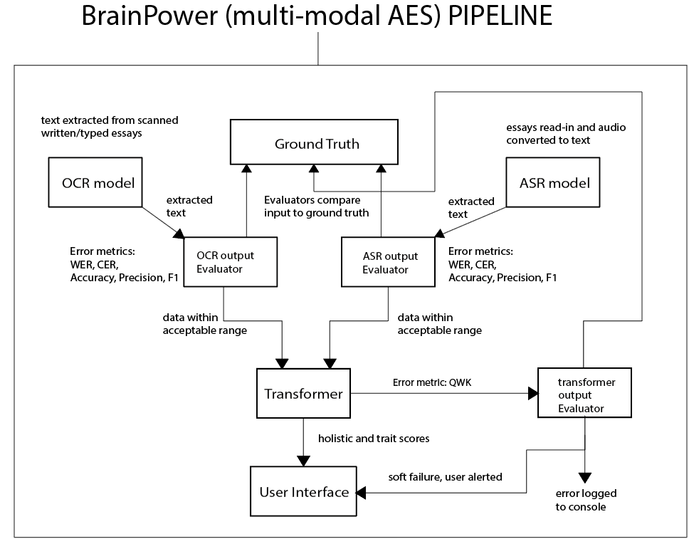 Figure 1 Architecture of BrainPower
The diagram above shows a high-level design of the BrainPower system for development and testing. The system comprises three (3) components:
- A pre-trained ASR model – OpenAI Whisper – faster-whisper-medium
- A pre-trained OCR model - PaddleOCR
- The pre-trained core – a transformer – DeBERTAa
The ASR model transcribes spoken essays to machine-readable text. The OCR model, (PaddleOCR), detects, recognises and represents text from images, as machine-readable text. The output from the components is evaluated against the set thresholds for average log probability, compression ratio and confidence scores and are classified as “pass” or “fail” accordingly. DeBERTa analyses, scores, and outputs a holistic score and four (4) trait scores. The routing logic comprises the OCR and ASR output evaluators. Essays that have text representations classified as “fail” are routed to the human scorer for marking.
The properties of each file, along with the original and normalised essays, the transcription data, detection data, recognition data, evaluation data, accuracy statistics, and scores are saved to the database. The trait and holistic scores are retrieved from the database and displayed to the user via the web interface.

3.2 System Workflow

The following three (3) typical use-cases illustrate the principal workflows supported by the system.

Use Case 1: Image-based essay submission
The user submits an image of a handwritten or typed essay via the user interface. The system routes the image to the OCR component for processing. The OCR component detects text regions, recognises text and represents text in a machine-readable format. The text is then routed to the OCR output Evaluator. The OCR Evaluator calculates the average confidence score for the whole essay. If this score is above the confidence threshold, then essay is classified as “pass” and routed to the transformer for scoring. Otherwise, the essay is classified as “fail” and routed to the human scorer.
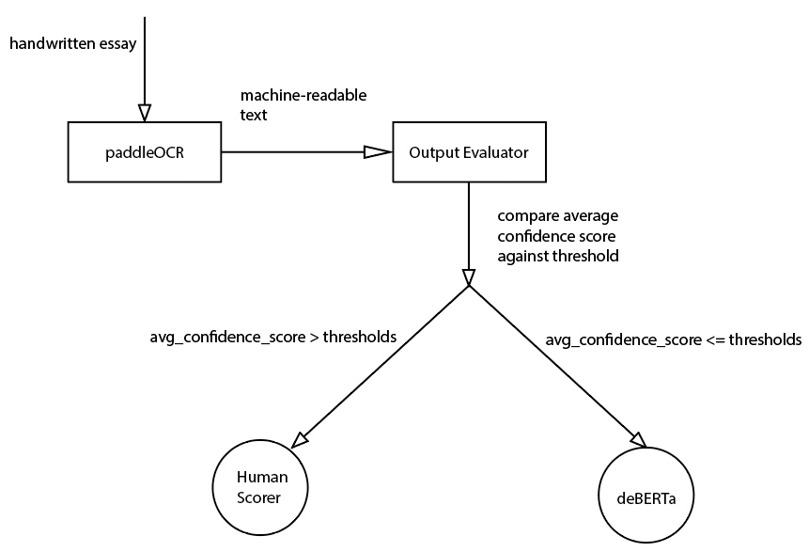

Use Case 2: Audio-based essay submission
The user submits a recorded essay to the ASR/STT component via the user interface. Whisper then transcribes the audio outputting machine-readable text. The ASR Evaluator calculates average log probability (avg_logprob) and the compression ratio. If either the log probability drops too low (indicating low confidence) or the compression ratio is too high (indicating the model is hallucinating), then essay is classified as “fail” and routed to the human scorer. Otherwise, the essay is classified as “pass” and routed to the transformer for scoring.
.
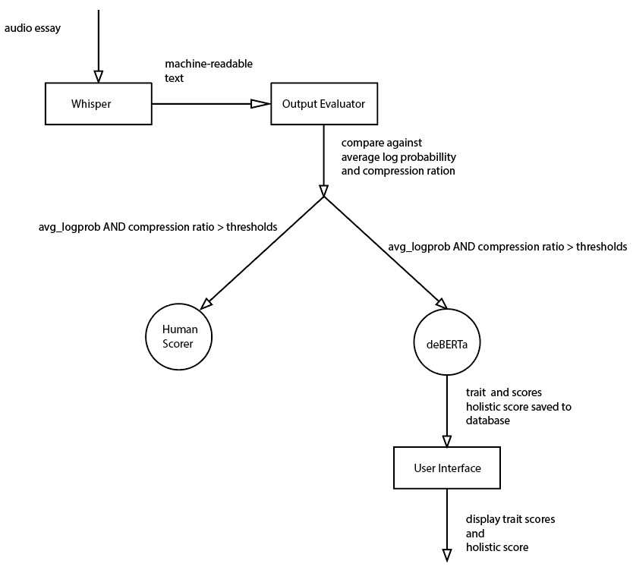
Use Case 3: Machine-readable essay submission
An essay in machine-readable format is routed to DeBERTa for evaluation and scoring. The model processes the text, evaluates and scores the essay. The Transformer scores the essay, the scores and other relevant data are saved to the database and finally, the trait and holistic scores are displayed to user via the web interface.
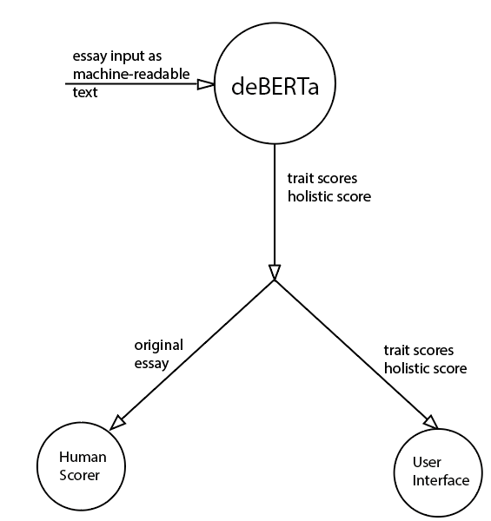

3.3 Component Selection

The Transformer model
DeBERTa was selected as the essay scoring component of BrainPower, based on its performance on SuperGLUE benchmarks and achievement of high QWK scores on AES tasks. The ASAP++ dataset preserves the essays and prompts of ASAP 1.0 but adds trait-level annotations. DeBERTa was fine-tuned using the essays and prompts from ASAP 1.0 and the trait-level annotations from ASAP++. This enabled the system to produce trait and holistic scores while retaining an interpretable scoring structure.
The OCR model
PaddleOCR was selected as the OCR input component of BrainPower. Although research has shown Tr-OCr outperforming PaddleOCR on some handwriting benchmarks, PaddleOCR was chosen because BrainPower needs an OCR component that can process a full page of text. Tr-OCR was designed to detect, recognize and represent a single line of text. Furthermore, PaddelOCR has robust and proven text detection and recognition models that have been pretrained to detect, recognise and represent a full page of handwritten text
The ASR/STT model
Whisper was selected as the ASR/STT component of BrainPower, to transcribe spoken essays, due to is reliability and state-of-the-art performance. It also satisfies the requirement for a pretrained model. Whisper has been trained for extended periods on very large datasets, which contain samples of audio from diverse speakers. It has consistently performed very well, even in experiments with little to no training, outperforming other models.

3.4 User Interface Design

The image below describes the layout of the user interface of BrainPower. The user interacts with the system via a web browser.

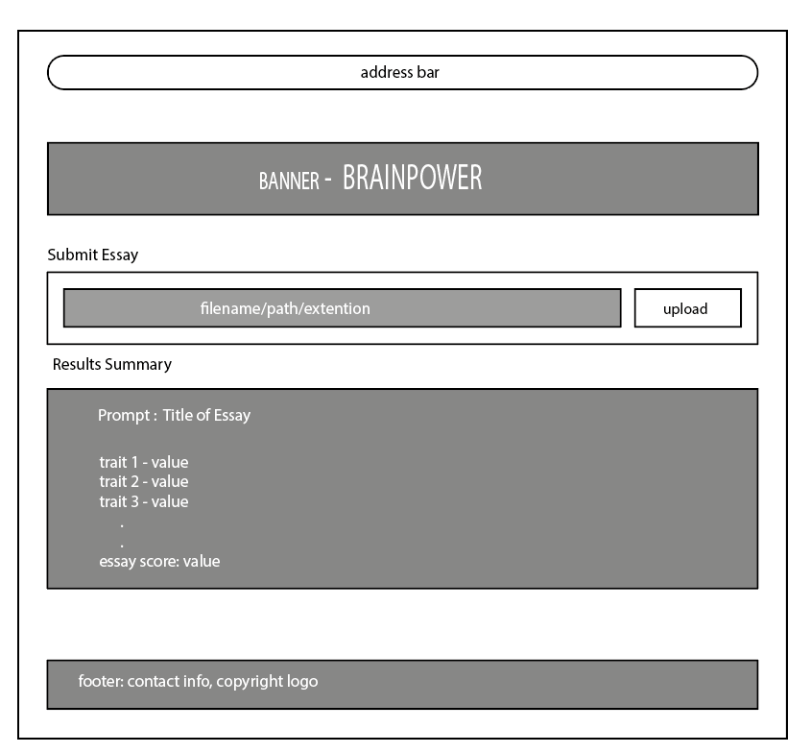
Figure 2 User interface for BrainPower system

Components of the User Interface:
- Banner: this section displays the name of the application and may contain links or a form for user login in future upgrades
- Submissions: this section is designed to allow the user to upload spoken essays as .wav files and handwritten essays as .jpeg files. The user is required to click the upload button to submit an essay and initiate the evaluation and scoring process.
- Results: this section displays DeBERTa’s output – trait and holistic scores.
- Footer: this section contains copyright data as well as links to sections for correspondence such as contact us form/page. This section does not contribute to the pipeline however it does contribute to the overall aesthetic of the system and follows the conventional web interface design paradigm.

3.5 Scope
This section lists the components and functionality that BrainPower will provide along with the components and functionality that are beyond the scope of this assignment.
In-scope
- User Interface – Webpage (user interface), supported by the Django Web Framework
- OCR models:
  - PaddleOCR - PP-OCRv6_medium_det
  - PaddleOCR - PP-OCRv6_medium_rec
  - English Language only
- STT/ASR model – OpenAI – faster-whisper-medium
  - English language only
- Transformer model – Microsoft – deberta-v3-base
  - English language output only
- Local execution on the user’s machine
- Database – SQLite3
Out of scope
- Multi-lingual input/output, limited to English
- Multiple choice exams evaluation
- Long answer questions evaluation
- Reading comprehension exercise evaluation
- (scene text) Essays with visual prompts/visual content such as a scene along with a prompt requiring students to write about the scene.
- Text-to-audio conversion
- Multiple input spoken and written essay formats

3.6 Data/ System Design

The Database:
SQLite3 was chosen because it comes bundled with Django and it is a lightweight application that is designed specifically for prototyping. The database only stores textual data and paths to both image and audio files. Image and audio files are stored locally to avoid bloating the database and for speed optimization. The database comprises five tables – Essay, Feature, Score, Metric and Submission.
The essay table stores the prompt, the original essay, the normalised essay, a date stamp and the status of processing. The researcher chose to inherit from Django’s TextChoices class for the essay status options. This approach is officially recommended by Django for enum-type fields. It ensures data consistency and validity.
The Feature table stores the word-count, sentence-count and average sentence length. The Score table stores the trait scores (content, organization, word choice, sentence fluency, conventions) and the holistic score for an essay. The Metric table stores the average log probability and compression ratio from the ASR output evaluation and the average confidence score from the OCR output evaluation. The Submission table stores the format of the submitted essay – typed, spoken or handwritten. The TextChoices class is also used to ensure valid data is stored in the database.
Essential Classes
EssayEditor Class
This class encapsulates most of the functionality to extract features from, normalise and display an essay. For speed and storage efficiency, regex patterns are compiled and along with rules, stored as class attributes.

BatchDataOperator
This class encapsulates a list of detail dictionaries, and each dictionary stores the file properties e.g. size, and extension along with the development metrics – WER and CER. This class also displays five representative sample from best to worst for development purposes to visually inspect the output from ASR and OCR components. To adhere to the DRY principle, this class also calculates and stores the metrics for the production/live system. This design precludes having two separate classes – one for development and the other for the live system. These metrics are the average log probability and compression ratio obtained from Whisper and the confidence scores obtained from PaddleOCR, which are used to calculate the average confidence score. This class also allows the developer to set the thresholds for the ASR and OCR evaluators both during development and for production. Further, all EssayEditor objects are stored for a batch in a single BatchDataOperator object allowing for the calculation on the batch.
Requires some talk of DeBERTa after it has been implemented.

Chapter 4

Implementation

4.1 Implementation Environment

- Operating System: Windows 11 Professional
- IDE: Jupyter Notebook
- Python: 3.11.9
- Hardware:
  - Processor: AMD Ryzen 7 5700G 8-Core
  - RAM: CORSAIR Vengeance LPX DDR4 32GB
  - GPU: ZER-LON GeForce GTX 1660 Super 6GB GDRR6 192Bit PCIE 3.0X16
- Dataset: ASAP 1.0
- OCR Model: PaddleOCR PP-OCRv6
- ASR Model: faster-whisper-medium
- Transformer Model: DeBERTa
- Django: 5.2.16
- Database: SQLite3

4.2 Data Processing and Management

Dataset Loading
The system utilized the pandas read_csv method to load the data into memory. For image and audio files, the get_files_metadata function passed the path of the data folders as an argument to the Path class, instantiating a Path object. This object was then iterated through returning individual objects each representing a file in the folder. The metadata of each object was then extracted, assigned to corresponding keys in a dictionary, and stored in the files_metadata list, which was then returned to the calling code.
Text Normalisation
The pipeline passed all output text to the EssayEditor constructor to instantiate an EssayEditor object. Normalisation was handled by the normalise_text method. Upon entry, it invoked the Python string lower method to convert the text to lowercase. Next, compiled regular expression (regex) patterns were applied to replace spoken symbols and symbol-word-combinations with their grammatically correct, written forms (e.g. replacing ‘@caps1’ with ‘at caps one’). The resulting text was then cleaned of any extraneous punctuation which was replaced with empty strings.
Batch Processing
The BatchDataOperator class was designed with ten (10) methods to manage aggregate data. It contained three dictionaries for storing statistical data for the batch: WER and CER statistics (mean, median etc.), and evaluation statistics, such as the total pass classifications and fail percentage. The WER and CER thresholds were set on initialisation, as these values are essential to evaluating the performance of the ASR and OCR during the development stage. To calculate batch statistics, the data for a particular metric was retrieved from each EssayEditor object and stored in a list. The list is passed to the get_stats_for_list method, converted to a NumPy array and the NumPy’s statistical functions were invoked to calculate the necessary stats. The final data was then stored in the appropriate batch-level dictionary.

4.3 OCR Implementation

Model loading
Implementation began by initialising a PaddleOCR object. The parameters, PP_OCRv6_medium_det and PP_OCRv6_medium_rec, were selected as the detection and recognition models, respectively. The engine parameter was set to “transformers”, while the use_doc_orientation_classify, use_doc_unwarping and use_textline_orientation parameters were all set to True, to dynamically handle curvature and distortion present in images captured with handheld devices.
Following the parameter-configuration-selection experiments, the text_det_unclip_ratio, text_det_limit_side_len and text_det_box_thresh parameters were set to 1.5, 960 and 0.4 respectively. The text_det_unclip_ratio controls the bounding-box dilation and was adjusted to prevent clipping of long cursive ascenders or descenders such as ‘g” or “l”. The text_det_limit_side_len was set to 960 to prevent the image from being downscaled too aggressively or upscaled into overlapping lines, preserving the topological integrity of the handwriting. Finally, the text_det_box_thresh set to a low value of 0.4, to allow the model to successfully detect light handwriting, such as light pencil strokes. All other parameters retained their default values.
Detection
The models predict () function was called to detect text regions. Effectively segmenting the image into several text regions in bounded polygons.
Recognition
The model represented detected text based on recognition confidence.
Processing output
The output was passed to the EssayEditor’s constructor to initialise an EssayEditor object which allowed the output text to be normalised. This object, along with all other metadata for a processed file, was stored in the details list of ocr_batch object, an instance of the BatchDataOperator class. The WER and CER percentage scores were also calculated and stored for each processed file separately and for the whole batch.
Error-rate calculation
The calculate_wer_and_cer_rates function was invoked and passed the reference essay and the normalised output from PaddleOCR. This function used the jiwer module to calculate the error rates and returned a list with the results.
Evaluation Logic
The logic correctly classified output that had either WER or CER percentage scores below their respective thresholds as “pass”, and “fail” otherwise. The essays classified as “fail”, were correctly assigned for manual scoring and those classified as “pass” were forwarded to DeBERTa for scoring.

4.4 ASR Implementation

Model loading
The model was loaded by initialising an object and passing medium, cuda, int8_float16, and 16 as arguments for model_size_or_path, device, compute_type, and cpu_threads, respectively. This configuration represented the best configuration from the configuration-selection experiments. CUDA was selected to leverage the capability of the NVIDIA GPU which is significantly more performant than the CPU. Mixed-precision quantization (int8_float16) was chosen to minimize the storage footprint in memory by using fewer digits to represent the data. The process of loading the model was timed to alert the researcher in the event of a malfunction or hang.
Audio loading
The audio files were processed as a batch. This was achieved via an enclosing loop that extracted a file object from the files_metadata list on every iteration. Librosa’s load method was the invoked, passing the path to the audio file and the target sample rate. The returned data (the vector of numerical data representing the features of the audio signal and the sample rate) were unpacked and stored in corresponding variables. The get_duration method was invoked to retrieve the file duration which was subsequently stored in the details dictionary.
Audio Transcription
The transcribe method of the Whisper model was invoked. The arguments passed were the audio signal vector, “en” for the language parameter, a beam_size of 2, and vad_filter was set to True. Setting the language explicitly to English saved processing time as the model did not have to spend compute cycles detecting the language. Setting the beam size to 5 provided the best balance between accuracy and computational efficiency.
Finally setting the Voice Activity Detection (VAD) filer to true reduced transcription time by forcing the model to ignore long periods of silence in the audio. After transcription, the segments were combined into a single text string by invoking Python’s join () function on the output of a list comprehension, which extracted individual text segments from Whisper’s segment generator. The combined string was then passed as an argument to the EssayEditor constructor during the initialisation of the whisper_output object. The text was subsequently normalised, evaluated against the error thresholds, assigned a “pass” or “fail” classification and finally, saved to the whisper_batch object (an instance of the BatchDataOperator class), as described in section 4.2.

4.5 AES/Transformer Implementation

This is where your DeBERTa implementation belongs.
Explain:
- Prompt construction
- Input format
- Rubric
- Model invocation
- Structured output
- Score extraction
- Feedback generation
- Storage
And this is important because your project has changed direction.
Your final report should describe the final implementation, not the implementation you originally intended to build.

4.6 Evaluation/Routing Logic

Evaluation of ASR and OCR component output was a two-step process. First, the global calculate_error_rates function was invoked, passing the reference and normalised essays (ASR/OCR output) as arguments. This function then called both the wer and cer functions from the jiwer module, to calculate the word error rate and character error rate, respectively. The calculate_error_rates function then returns a dictionary with two key-value pairs – “wer” mapped to the calculated word error rate, and “cer” mapped to the calculated character error rate.
Secondly, a logical test was performed to evaluate these metrics against the predefined system thresholds. The evaluation_status variable was assigned the classification of “pass” if both the WER and CER values were equal to or less than their respective thresholds, and “fail” otherwise. The classification was stored under the key “Evaluation Status” in the details dictionary for every processed file, which was subsequently appended to the batch object’s detail_list. Ultimately, this evaluation status dictated the routing of the essay: outputs classified as “fail” were routed to human scorer for manual grading, while those classified as “pass” were forwarded to DeBERTa for automated evaluation.
Double check, since update_eval_stats is for development, Explain update_eval_stats() and how robust it is, thresholds can change it merely used the pass fail against wer and cer to update the count

4.7 System Integration

Finally explain how the components were connected.
That gives Chapter 4 a very natural progression:
Environment → Data → OCR → ASR → Transformer → Evaluation logic → Integration
That's much stronger than "Procedure."

4.8 System Deployment/Implementation Details

Scripts to download models
Scripts to upload data for processing
Installation instruction, requirements.txt installation
The system will be prototyped using Jupyter Notebooks. This resource contains sufficient facility to demonstrate the utility of the AES system and catch any bugs prior to moving to a production environment. The production system will be implemented as a web application using the Django framework.

CHAPTER 5

Evaluation

5.1 Evaluation Methodology

Explain:
- What you evaluated – paddleOCR wer, cer, confidence scores, Whisper wer, cer performance on 30 samples
- Why you evaluated it – to determine suitability of inclusion in the system, results would indicate reliability, consistency, accessibility, potential for serving as assistive technology
- Dataset asap 1.0, asap++ as it provides trait level annotations
- Human samples
- Ground truth – asap 1.0 dataset, reference essay essay 1 of prompt 1
- Metrics wer, cer, conficence scores
- Thresholds -0.090 wer, 0.050 cer, why initially selected heuristically then not adjusted after visual inspection, they reliably route essays based on degree of readability/interpretability
- Experimental setup – configure models, select best, use selected mode on batch
- Why these metrics were selected, standard practice, other studies cited them, best for development system, ground truth essay or reference essay will not be available for live system – for live system average log probability, compression ratio and confidence scores will be used, qwk can be use on live system but only after batch if human scored marks and records trait and holistic scores for batch defeating the purpose of having AI assistance.
This is where your 25/26/27 samples, WER, CER, QWK, etc. need to be explained.

Procedure
To evaluate the performance of the system the following approach was used:
OCR Component – WER and CER metrics were calculated and used to determine whether the output should be sent to the core for further processing or flagged for human scorer intervention
ASR Component- WER and CER metrics will be calculated and used to determine whether the output should be sent to the core for further processing or a flag raised for human scorer intervention
AES – will output trait scores along with a QWK which will be used to describe proximity of the system’s scores to that of human scorers along
Datasets –this research will use the scores for the essays of Prompt1 of the ASAP 1.0, along with the trait level annotations from the ASAP++ dataset for fine-tuning the transformer and evaluating the complete BrainPower AES application

5.2 Testing Plan

The Dataset
A sample population of 28 students between the ages of 12 and 21 was randomly selected. This age range was selected because it loosely aligns with the age range of the high schooler who wrote the original essay. The size of the sample population was also selected to closely align with the population size of a typical classroom. This gave an accurate demonstration of the system’s capacity to reliably and efficiently score every essay from a single English Language class in one batch.
Each student was required to submit a photograph of a handwritten copy and an audio recording of the first essay of the first prompt of the ASAP 1.0 dataset. This produced a total of fifty-six samples, twenty-eight handwritten and twenty-eight spoken, for testing and evaluating the individual components and the whole system.
The main reason for selecting only the first essay of the first prompt, was consistency. Furthermore, comparing twenty-eight audio transcriptions and twenty-eight sample of recognised text, of the same essay, all from the same individuals produced more reliable results for assessing the accuracy of the components’ output and justified their inclusion in the AES pipeline.
The Models
To obtain the model parameter configurations which produce the most accurate, consistent and reliable results. Multiple configurations of both Whisper and PaddleOCR were tested on a single randomly selected handwritten and spoken essay. The criteria used for selection was the lowest combined WER and CER numbers along with the lowest processing time. The best performing configurations were subsequently used to process the respective batches of data samples.
DeBERTa was fine-tuned [specify how] on the ASAP1.0 dataset but prompted with the ASAP++ trait level annotations. Then the model was used to batch process the machine-readable essays and the QWK was calculated thereafter.

5.3 Unit Testing

Keep this but compress it.
Your UT001–UT010 tests establish that your fundamental functions work.
You don't need huge amounts of prose around them.
A concise table is enough, followed by a short interpretation.
For example:
Unit testing confirmed that the core data-loading, text-normalisation and error-rate calculation functions operated as expected. This established a reliable foundation for subsequent component testing.
Then move on.

5.4 OCR Evaluation

5.4.1 OCR Test Procedure
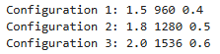
Figure 5.4.1 List of parameter configurations for parameter selection
Three parameter configurations, for text_det_unclip_ratio, text_det_limit_side_len, and text_det_box_thresh, respectively, as shown in figure 5.1 above, were tested on five sample handwritten essays. The configuration that achieved the lowest average WER and CER, was implemented to process the batch of essays.
A visual inspection of the detected regions was done to determine if the detection model, accurately identified areas in the image where there was text. Figure 5.4.2 confirms that the best performing configuration also accurately selected text regions.
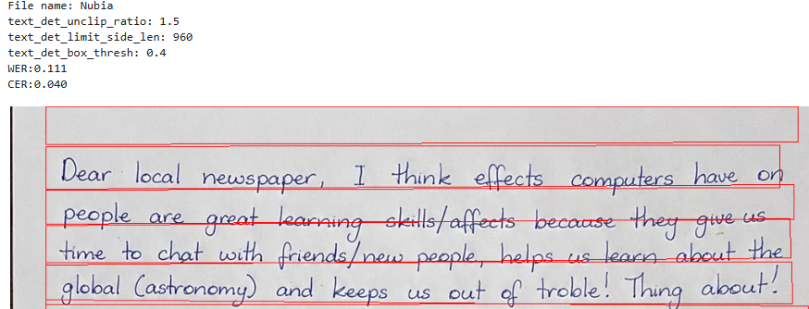

5.4.2 OCR Results
Initially, every output was classified as “fail” when evaluated. The main reason being, the CER and WER thresholds were too low and the requirement for the output’s WER and CER to both be below their respective threshold.
The mean WER was high, 33.77% while the mean CER, 17.04% was relatively low. The mean WER was 11.11%, which was 1.11 percentage points above the WER threshold. The min CER, 4.0%, is below the CER threshold, 5.0%. This however only represents a unique case, as there is only one, recorded CER pass in the batch. The WER and CER fail percentages were very high, 100% and 94.43%, respectively.
5.4.3 OCR Error Analysis
The output with the lowest WER and CER had percentage scores of 11.11% and 4.0% respectively. Although this essay’s WER was about two percentage points above the WER threshold, a visual inspection revealed that it was readable and decipherable, which indicated that the evaluation logic was too strict. PaddleOCR’s recognition model performed accurately, recognising most strings with confidence scores above 90% on average, as is shown in figure 5.4.3 below.
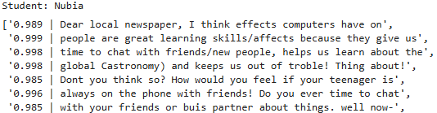
Figure 5.4.32 Confidence score for OCR output, recognised text
This essay would be accurately scored by the transformer, because it consistently maintained its semantic meaning although there were some obvious word and character errors. There are a few misrepresentations for example “(astronomy)” is represented as “Castronomy)”, likewise “trouble” for “trouble”. (where is quote from, use in lit review to show why deberta is a good choice, expand on subword tokenisation, there) However, as was discussed in the literature review, transformer models like DeBERTa are incredibly robust to minor spelling errors and due to sub-word tokenisation, and would still accurately score the essay even with a few minor spelling errors present.
Further inspection revealed that essays with a WER around 20% and a CER around 7% were readable and decipherable and could easily be scored by the transformer. Thus, the decision was made to adjust the WER and CER threshold to 20% and 8% respectively. The batch was processed using the new thresholds, and the pass percentage jumped from 0 to 17.85%. This increase, however, was not sufficient to support PaddleOCR being included in the AES pipeline as assistive technology since more than 80% of the batch had to be scored manually.
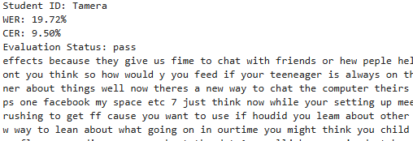
Figure 5.4.4 Indecipherable essay "passed" by evaluation logic

Furthermore, Tamera’s essay, shown in Figure 5.4.4, was initially classified as “pass” having a WER of 19.72% and CER of 9.50%, both below the corresponding thresholds. However, visual inspection of the output revealed several spelling errors, and the essay was difficult to decipher. Further inspection found that essays with a CER above 8% were generally not sufficiently decipherable to be reliably scored by the transformer. Consequently, the evaluation logic was further refined to classify only OCR output with a CER at or below 8% as “pass”. This stricter criterion reduced the number of essays classified as “pass” and increased the number assigned to manual marking, providing empirical evidence that PaddleOCR did not provide sufficient reliability for inclusion as an assistive technology within the proposed system.

5.5 ASR Evaluation

5.5.1 Model Configuration Experiments
To select the optimum ASR configuration, a list of 6, 2-tuple – (model size, compute_type) parameter configurations were used as shown in screenshot 5.5.1 below.
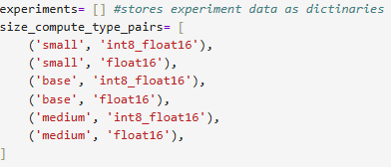
Figure 5.5.1. Model configuration list
Five samples were selected based on clarity, lack of background noise and audibility, after each was listened to by the researcher.
The experiment produced a total of 30 configurations – 5 per each model size, compute_type, beam size combination. The beam size was gradually increased from 1 to 5 for each model size – compute-type pairing. The results are shown in the figure 5.5.2 below.
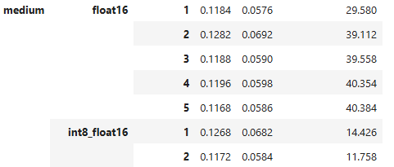
Figure 5.5.2 ASR model parameter configuration results
The configuration (medium=model, int8_float16='compute_type', beam_size=2) demonstrated a good balance between computationally efficiency and accuracy, achieving a mean WER of 11.72% and a CER of 5.85%, one of the lowest CER of all configurations. It also transcribed the 5 samples in under 12 seconds. The medium model, with compute_type= float_16 and beam_size=3, achieved the lowest WER and CER of all configurations, however, its transcription time is more than 3 times greater than the model described previously. Therefore, the configuration that was used to transcribe the batch was the medium model, with quantization int8_float16 and a beam size of 2. The VAD filter remained set to True for all experiments to maintain efficiency. Section 4.2 ASR Implementation gives a comprehensive explanation of the VAD filter’s operation.

5.5.2 WER/CER Results from Batch Transcription
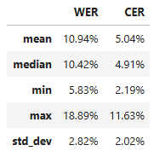
Figure 5.5.3. WER and CER results
Figure 5.5.3 shows the mean WER, 10.94%, is slightly higher than the acceptable threshold of 9.0%. The max WER however, differs from the min by more than13 percentage points – indicating variation in transcription accuracy across the samples. The median WER, 10.42% is slightly above the threshold while the CER, 4.91%, is slightly below the threshold.
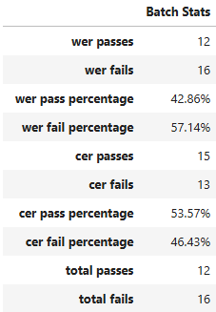
Figure 5.5.4. WER and CER Results

Figure 5.5.4 shows that CER passes were roughly 10% more than those classified as fails. The model seems to more consistently, inaccurately transcribe, whole words rather than individual letters or characters.
The most accurately transcribed essay has a WER of 5.83%, and a CER of 2.18%. Perusal of this essay shown in figure 5.5.5, confirmed the results since it was transcribed very accurately and the errors from transcription did not detract from the semantic of the essay.
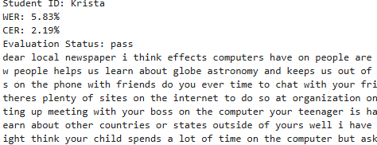
Figure 5.5.5 Screenshot of accurately transcribed essay
The essay shown in figure 5.5.6, with the median WER percentage has a WER slightly above the acceptable WER threshold, and a CER slightly below the acceptable threshold.
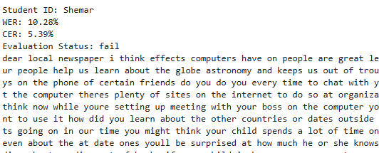
Figure 5.5.6. Transcription with high WER and low CER
From a visual inspection of this essay, it is apparent that most of the wrongly transcribed words are still decipherable by a human scorer. For example, Whisper transcribed “or young people” as “on your people”. This discovery, however, does not motivate an adjustment to the current thresholds as this substitution, though recognisable to a human scorer, is likely to affect the transformer’s interpretation, resulting in an inaccurate score.

5.5.3 Pass/Fail Classification
Whisper transcribed 28 essays. Twelve (12) of the 28 essays, 42.86%, were at or below than WER threshold, and were classified as “pass”, while 16 transcriptions, 57.14%, had WER percentage scores above the threshold and were classified as “fail”. This indicates that although most essays were assigned for manual scoring, a significant minority were assigned for scoring by the transformer.
5.5.4 Representative Transcriptions
Figures 5.5.7 and 5.5.8 are of transcriptions with WER and CER percentage scores between the min and median, and the median and max, respectively.
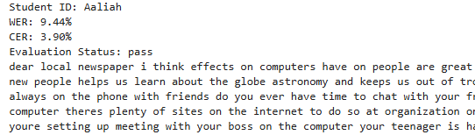
Figure 5.5.7 Transcription with WER between min and median
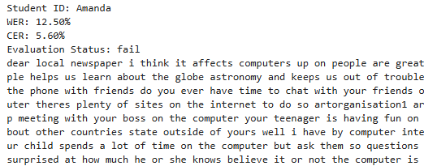
Figure 5.5.8 Transcription with WER between median and max
The transcription of Aaliah’s voice is reasonably accurate with a WER of 9.44% and a CER of 3.90%. The transcription of Amanda’ voice although classified as “fail” is still readable and interpretable by a human scorer.
The most inaccurate transcription is still decipherable by a human scorer, as seen in figure 5.5.9 below.
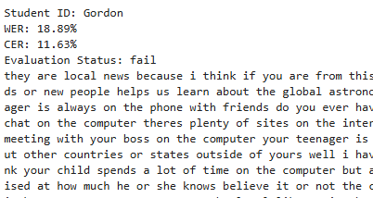
Figure 5.5.9 Most inaccurate transcription
This indicates that the evaluation logic worked as intended, demonstrating sensitivity to transcriptions with high WER percentages, preventing them from moving through the pipeline.
5.5.5 Analysis
The results from the batch transcription support the inclusion of Whisper in the AES pipeline as an assistive technology. More than forty percent (40%) of the spoken essays were accurately transcribed and forwarded to DeBERTa for scoring. This significantly reduced the human scorer’s workload down to around sixty percent (60%). The results also proved the accuracy and reliability or the evaluation logic, correctly routing transcriptions to the appropriate scorer based on their evaluation status, assigned after calculating the WER and CER. The evaluation logic also prevented the transformer from using up system resources to score essays that would inevitably be inaccurately scored due to the poor quality of the transcription.

5.6 Transformer/AES Evaluation

This needs to be a substantial section because otherwise your evaluation is heavily weighted toward OCR/ASR.
You need to demonstrate:
- Scores generated
- Trait scores
- Holistic scores
- Comparison against human scoring
- QWK
- Possibly precision/recall/F1 if applicable
- Examples
- Analysis of disagreements
This is particularly important because the rubric asks:
"Are the evaluation results used to critically analyse the project with respect to the aims and objectives?"

5.7 Integration/System Evaluation

Here your IT and FST tests can come together.
Rather than having dozens of isolated tests, explain:
Does the complete pipeline actually work?
For example:
Image → OCR → evaluation → AES → result
and
Audio → Whisper → evaluation → AES → result
Then discuss successful and unsuccessful routes.

5.8 End-User/Usability Evaluation

Your EUT and usability questionnaire belong here.
Explain:
- Participants
- Procedure
- Questions
- Results
- Interpretation
If you actually collect usability data, present the results graphically.

5.9 Overall Evaluation

This is the section I think you're currently missing.
This is where you step back and answer:
Did BrainPower achieve its objectives?
Discuss:
Successes
- Multimodal input
- Accessibility
- OCR/ASR integration
- Error detection
- Human fallback
- Interpretability
Failures
- OCR accuracy
- Whisper failures
- Transformer limitations
- Dataset limitations
- Computational limitations
Limitations
- Sample size
- One prompt
- English only
- Ground-truth requirements for WER/CER
- Model limitations
- Hardware
- etc.
Overall assessment
This directly addresses the rubric's requirement for a critical evaluation of the project as a whole.

Chapter 6

Conclusion

6.1 Conclusion

6.2 Future improvements:

Improved User interaction:
- A human scorer can mark an essay rejected by the OCR or ASR evaluators, via the user interface and save the changes to the database.
- A human scorer can toggle the of display highlighted tokens to determine the model’s detection capabilities
- A Human scorers can assign confidence scored to words to improve the model’s recognition capabilities.
- A Human scorer can flag word/sentence false positives. This data can be stored in a dictionary. This data can be used to train the model later.
Improved Feedback
- The system should directly, inform students of issues with their submissions
- The system should provide suggestions for improving submissions e.g.
  - Highlighting words/sentences that have low confidence score, suggesting a rewrite and resubmission
System Expansion
- The user can submit files in multiple formats
- Combining interpretable features such as word count, sentence count, spelling errors with transformer output, or using them to engineer a trainable system.
- The system can process essays submitted as multiple files. For example, the system merges multiple images of essays submitted as separate files in to a single file and routes to the OCR component for processing.

Reference List

[1] W. Xu, R. Mahmud, and W. L. Hoo, "A Systematic Literature Review: Are Automated Essay Scoring Systems Competent in Real-Life Education Scenarios?" IEEE Access, vol. 12, pp. 77639–77657, 2024, doi: 10.1109/ACCESS.2024.3399163.
[2] K. Taghipour and H. T. Ng, "A Neural Approach to Automated Essay Scoring," in Proceedings of the 2016 Conference on Empirical Methods in Natural Language Processing (EMNLP), Austin, TX, USA, Nov. 2016, pp. 1882–1891, doi: 10.18653/v1/D16-1193.
[3] P. Lagakis and S. Demetriadis, "Automated Essay Scoring: A Review of the Field," in Proc. 2021 International Conference on Computer, Information and Telecommunication Systems (CITS), Istanbul, Turkey, Jul. 2021, pp. 1–5, doi: 10.1109/CITS52676.2021.9618476.
[4] J. Yang, "Automated Essay Scoring in Education," in Proc. 2024 4th International Conference on Educational Technology (ICET), 2024, pp. 170–175, doi: 10.1109/ICET62460.2024.10868446.
[5] A. M. Elmassry, N. Zaki, N. Alsheikh, and M. Mediani, "A Systematic Review of Pretrained Models in Automated Essay Scoring," IEEE Access, vol. 13, pp. 121902–121917, 2025, doi: 10.1109/ACCESS.2025.3584784.
[6] S. S. Han and M. Myint, "A Comparative Study of LSTM, Bi-LSTM, and BERT for Automated Essay Scoring," in Proc. [Insert Conference Name], [Year], pp. [pages], doi: [DOI].
[7] R. Dadi and S. K. Sanampudi, "A Robust Model for Automated Essay Scoring System," in Proc. 2024 International Conference on Computational Intelligence and Sustainable Engineering Solutions (CISES), 2024, pp. 1–6, doi: 10.1109/CISES62520.2024.10712145.
[8] P. Jain, K. Taneja, and H. Taneja, "Which OCR Toolset is Good and Why? A Comparative Study," in Proc. 2021 International Conference on Computational Performance Evaluation (ComPE), Shillong, India, 2021, pp. 640–646, doi: 10.1109/ComPE53109.2021.9752243.
[9] M. Li, T. Lv, J. Chen, L. Cui, Y. Lu, D. Florencio, C. Zhang, Z. Li, and F. Wei, "TrOCR: Transformer-Based Optical Character Recognition with Pre-trained Models," arXiv preprint arXiv:2109.10282, 2021.
[10] M. T. Mostafa, E. R. Rhythm, M. H. K. Mehedi, and A. A. Rasel, "Advancements in Optical Character Recognition for Bangla Scripts," in Proc. 2023 International Conference on Electrical, Computer and Communication Engineering (ECCE), 2023, pp. 1–6.
[11] R. Hussain, A. Raza, I. Siddiqi, K. Khurshid, and C. Djeddi, "A comprehensive survey of handwritten document benchmarks: Structure, usage and evaluation," EURASIP Journal on Image and Video Processing, vol. 2015, Art. no. 46, 2015, doi: 10.1186/s13640-015-0102-5.
[12] A. K. Meghana, H. Gupta, and P. Dubey, "Enhanced Text Extraction from Low-Quality Legacy Documents Using TrOCR Assisted by Line Detection," in Proc. 8th World Engineering Conference on Contemporary Technologies (WECON), 2025, doi: 10.1109/WECON68556.2025.11414621.
[13] J. Q. Cheok, K. C. Lim, and C. E. Si, "Maximizing Recognition Reliability: TrOCR Outperforms PaddleOCR in Challenging Container Automation Environments," International Journal of Research and Innovation in Social Science (IJRISS), vol. 9, no. 11, 2025, Art. no. 91100629, doi: 10.47772/IJRISS.2025.91100629.
[14] B. Wang, T. Zhao, L. Dong, Z. Yu, and Y. Qian, "Application of PaddleOCR in Power Consumption Environment Text Recognition," in Proc. 7th Int. Academic Exchange Conf. on Science and Technology Innovation (IAECST), 2025, pp. 1562–1566, doi: 10.1109/IAECST68792.2025.11415173.
[15] A. Elakkiya, K. Jaya Surya, K. Venkatesh, and S. Aakash, "Implementation of Speech to Text Conversion Using Hidden Markov Model," in Proc. 2023 International Conference on Intelligent Computing and Control Systems (ICICCS), 2023, pp. 1–5.
[16] M. S. Tabrej, K. J. Deb, M. A. Hakim, and S. Goswami, "Automatic Speech Recognition in the Modern Era: Architectures, Training, and Evaluation," in Proc. 2023 International Conference on Artificial Intelligence and Data Engineering (AIDE), 2023, pp. 1–6.
[17] G. Hinton, L. Deng, D. Yu, G. E. Dahl, A.-r. Mohamed, N. Jaitly, A. Senior, V. Vanhoucke, P. Nguyen, T. N. Sainath, and B. Kingsbury, "Deep Neural Networks for Acoustic Modeling in Speech Recognition," IEEE Signal Processing Magazine, vol. 29, no. 6, pp. 82–97, 2012, doi: 10.1109/MSP.2012.2205597.
[18] A. Radford, J. Kim, T. Xu, G. Brockman, C. McLeavey, and I. Sutskever, "Robust Speech Recognition via Large-Scale Weak Supervision," arXiv preprint arXiv:2212.04356, 2022.
[19] A. Vaswani, N. Shazeer, N. Parmar, J. Uszkoreit, L. Jones, A. N. Gomez, Ł. Kaiser, and I. Polosukhin, "Attention Is All You Need," in Advances in Neural Information Processing Systems (NeurIPS), 2017, pp. 5998–6008.
[20] K. Hlongwane, S. Mthethwa, and L. Manqele, "Enhancing Diversity in Inclusive Learning Classroom Using OpenAI Whisper Model," in IST-Africa 2025 Conference Proceedings, M. Cunningham and P. Cunningham, Eds., IST-Africa Institute and IIMC, 2025, ISBN: 978-1-905824-75-5.
[21] J. Su, Y. Yan, Z. Gao, H. Zhang, X. Liu, and X. Hu, "Multi-Granular Multimodal Essay Scoring," arXiv preprint arXiv:2505.13965, 2025.
[22] A. Algablan, R. Alshammari, and S. Alresaini, "Scoring Students' Answers Using OCR and GPT," in Proc. 2026 IEEE 5th International Conference on Computing and Machine Intelligence (ICMI), 2026, doi: 10.1109/ICMI68585.2026.11539856.
[23] J. Gao, Q. Yang, Y. Zhang, L. Zhang, and S. Wang, "A Bi-modal Automated Essay Scoring System for Handwritten Essays," in Proceedings of the 2021 International Joint Conference on Neural Networks (IJCNN), 2021, doi: 10.1109/IJCNN52387.2021.9533505.
[24] C. A. L. Baclayon, K. O. R. Costelo, J. J. L. Flores, and C. L. C. Sta. Romana, "Automated Handwritten Essay Evaluation in Moodle: Leveraging Google Vision OCR and Mistral 7B," in Proceedings of ICDTE 2024, ACM, Berlin, Germany, Aug. 07–09, 2024, doi: 10.1145/3696230.3696256.
[25] Y. Wang, W. Qu, and X. Ye, "Selecting Between BERT and GPT for Text Classification in Political Science Research," arXiv preprint arXiv:2411.05050, Nov. 2024, doi: 10.48550/arXiv.2411.05050.
[26] P. He, X. Liu, J. Gao, and W. Chen, "DeBERTa: Decoding-Enhanced BERT with Disentangled Attention," in Proc. International Conference on Learning Representations (ICLR), 2021.
[27] D. K. A, A. V. S, R. Aravindan, and A. Balamurali, "Sound Sight-A TTS and STT Integrated Model using OCR and ASR," in 2024 International Conference on Innovative Computing, Intelligent Communication and Smart Electrical Systems (ICSES), Chennai, India, Dec. 2024, pp. 1–5, doi: 10.1109/ICSES63760.2024.10910492.
[28] J. C. Obi, "A comparative study of several classification metrics and their performances on data," World Journal of Advanced Engineering Technology and Sciences, vol. 8, no. 1, pp. 308–314, Feb. 2023, doi: 10.30574/wjaets.2023.8.1.0054.
[29] S. Sathyanarayanan and B. R. Tantri, "Confusion matrix-based performance evaluation metrics," African Journal of Biomedical Research, vol. 27, no. 4S, pp. 4023–4031, Nov. 2024, doi: 10.53555/AJBR.v27i4S.4345.
[30] G. M. Foody, "Challenges in the real-world use of classification accuracy metrics: From recall and precision to the Matthews correlation coefficient," PLoS ONE, vol. 18, no. 10, Art. no. e0291908, Oct. 2023, doi: 10.1371/journal.pone.0291908.
[31] A. N. Chowdhury, S. Absar, A. A. Sami, F. Rahman, S. M. P. Mamun, and M. S. R. Kohinoor, "Performance analysis of Tesseract and EasyOCR for Bangla optical character recognition on the novel Bangla CrossHair dataset," in Proc. 2025 3rd Int. Conf. on Intelligent Systems, Advanced Computing and Communication (ISACC), 2025, pp. 1–6, doi: 10.1109/ISACC65211.2025.10969286.
[32] M. A. N. Hadi, M. Gul, M. Khan, G. N. Alwakid, and N. Z. Jhanjhi, "Benchmarking performance analysis of optical character recognition techniques," in Proc. 26th Int. Multitopic Conf. (INMIC), Karachi, Pakistan, Dec. 2024, pp. 1–6, doi: 10.1109/INMIC64792.2024.11004392.
[33] Y. Zhang, “A study on the translation of spoken English from speech to text,” Journal of ICT Standardization, vol. 12, no. 4, pp. 429–442, 2025, doi: 10.13052/jicts2245-800X.1244.
[34] M. Schubert, D. Duran, and I. Siegert, “Challenges of German speech recognition: A study on multi-ethnolectal speech among adolescents,” in Proc. Interspeech 2024, Kos, Greece, Sep. 1–5, 2024, pp. 3045–3049, doi: 10.21437/Interspeech.2024-1717.

Appendix A – Testing Documentation

A.1 Unit Tests
UT001- UT010

Test | Description | Expected Results | Actual Results
UT001 | Import dataset | Dataset loadedsuccessfully | Dataset loaded successfully
UT002 | Extract and display Promp1(see Appendix A) reference essay from ground truth the ground truth dataset | Reference essay successfully extracted from dataset and displayed | Reference essay successfully extracted from dataset and displayed
UT003 | Display Word Count | Number of words: 331 | Number of words: 331
UT004 | Display Sentence Count | Number of sentences: 16 | Number of sentences: 16
UT005 | Calculate and display the word error rate (WER) | Word Error Rate: 0.018 | Word Error Rate: 0.018
UT006 | Calculate and display the character error rate (CER) | Character Error Rate: 0.046 | Character Error Rate: 0.046
UT007 | Convert a body of text to lower case | Essay successfully converted to lower case | Essay successfully converted to lower case
UT008 | Normalise symbols | Symbols normalised successfully | Symbols normalised successfully
UT009 | Normalise spoken forms | Spoken forms normalised successfully | Spoken forms normalised successfully
UT010 | Clean text by removing all punctuation and extra spaces | All punctuation and extra spaces successfully removed from text | All punctuation and extra spaces successfully removed from text

A.2 OCR Component Tests
OCR001-OCR006
Test | Description | Expected Results | Actual Results
OCR001 | Access audio file(s) via specified path | Model loaded successfully. | Model loaded successfully.
OCR002 | Load audio file to librosa for signal conversion | Audio loaded successfully | Audio loaded successfully
OCR003 | Generate transcription for a single .wav file | Transcription performed successfully | Transcription performed successfully
OCR004 | Load whisper model(s) | Models loaded successfully | Model loaded successfully
OCR005 | Transcribe an audio recording | Recording successfully transcribed | Recording successfully transcribed
OCR006 | Save model configuration and experiment data. | Model configuration and experiment data successfully saved | Model configuration and experiment data successfully saved
OCR007 | Transcribe a batch of .wav spoken essay files | Batch of spoken essay files successfully transcribed | Batch of spoken essay files successfully transcribed

A.3 ASR Component Tests
ASR001-ASR008
Test | Description | Expected Results | Actual Results
CT007 | Access audio file(s) via specified path | Model loaded successfully. | Model loaded successfully.
CT008 | Load audio file to librosa for signal conversion | Audio loaded successfully | Audio loaded successfully
CT009 | Generate transcription for a single .wav file | Transcription performed successfully | Transcription performed successfully
CT010 | Load whisper model(s) | Models loaded successfully | Model loaded successfully
CT011 | Transcribe an audio recording | Recording successfully transcribed | Recording successfully transcribed
CT012 | Save model configuration and experiment data. | Model configuration and experiment data successfully saved | Model configuration and experiment data successfully saved
CT013 | Transcribe a batch of .wav spoken essay files | Batch of spoken essay files successfully transcribed | Batch of spoken essay files successfully transcribed
CT014 | Assign a transcription “pass” or “fail” based on its WER and CER values | Transcriptions successfully assigned “pass” or “fail” status based on WER and CER values | Transcriptions successfully assigned “pass” or “fail” status based on WER and CER values
CT015 | Save the WER and CER statistics for the batch of recordings | WER and CER statistics per batch saved | WER and CER statistics per batch saved

A.4 Transformer Component Tests
TF001 -
Test | Description | Expected Results | Actual Results
CT012 | Load model | The model loaded successfully
CT013 | Construct evaluation prompt | The evaluation prompt was successfully constructed
CT014 | Submit essay for scoring | The essay was successfully submitted for scoring
CT015 | Generate holistic score | A holistic score was generated successfully
CT018 | Generate trait scores (if possible) | Trait scores were successfully generated
CT016 | Generate feedback | Feedback was successfully generated
CT017 | Produce structured output (JSON or formatted response) | Output was structured successfully as JSON

A.5 Integration Tests
IT001-IT006
Test | Description | Expected Results | Actual Results
IT001 | Verify that OCR output is successfully passed to the transformer | The output was successfully passed to the transformer
IT002 | Verify that OCR evaluation metrics is successfully stored in the database | The output was successfully stored in the database
IT003 | Verify that ASR output is successfully passed to the transformer | The output was successfully passed to the transformer
IT004 | Verify that ASR evaluation metrics is successfully stored in the database | The output was successfully stored in the database
IT005 | Verify that the output from the transformer is successfully stored in the database | The output was successfully stored in the database
IT006 | Verify that the output from the transformer is successfully stored displayed to the user interface | The output was successfully displayed to the user interface

A.6 Functional System Tests
FST001-FST005
Test | Description | Expected Results | Actual Results
FST001 | System accepts an image of written essay, paddleOCR extracts text, OCR Evaluator determines the text recognition accuracy to be acceptable and forwards essay to DeBERTa | Trait and holistic scores are displayed via the interface
FST002 | System accepts an audio file of a spoken essay, Whisper transcribes audio, ASR Evaluator determines  transcription accuracy to be acceptable and forwards essay to DeBERTa | Trait and holistic scores are displayed via the interface
FST003 | System accepts an image of written essay, paddleOCR extracts text, OCR Evaluator determines the text recognition accuracy to be unacceptable | User is alerted of the evaluation and directed to mark the essay manually
FST004 | System accepts an audio file of a spoken essay, Whisper transcribes audio, ASR Evaluator determines  transcription accuracy to be unacceptable | User is alerted of the evaluation and directed to mark the essay manually
FST005 | The system calculates the QWK after the transformer scores a batch of essay | The system produced a QWK after the transformer scored a batch of essays

B.7 End-User Tests
EUT001-EUT004
Test | Description | Expected Results | Actual Results
EUT001 | User can upload image of written essay | User successfully uploaded an image of a handwritten essay
EUT002 | User can upload audio recording of spoken essay | User successfully uploaded an audio file of a spoken essay
EUT003 | User can interpret trait and feature scores | User successfully interpreted feature scored
EUT004 | User can interpret holistic score | User successfully interpreted holistic score

B.8 USABILITY TESTING
Statement | Strongly Disagree | Disagree | Neutral | Agree | Strongly Agree
The system is easy to use
The feedback is easy to understand
The scoring feedback is useful
The scoring feedback is verbose
The trait scores are reasonable
The holistic score is reasonable
The interface is well organised
The font size is appropriate
The colour scheme is clear
I would use this system again

Appendix B – Testing Documentation

B.1 Unit Testing

- Extract and display the reference essay – Essay 1 of Prompt 1

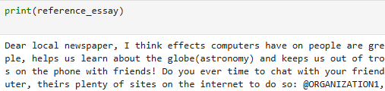
- Calculate and display word and sentence count from the reference essay

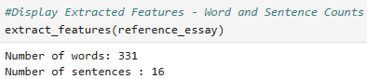
The natural language tool kit was used to tokenise sentences and words to provide a count that will later be used as a point of reference in determining the accuracy of the OCR detection and ASR transcription processes.
Purpose: Although these features will not contribute to the scoring of the essay by the transformer, they serve to satisfy the requirements for the system to be interpretable and explainable to human scorers.

- Calculate and display the word and sentence error rates

A copy of the reference essay was deliberately modified by appending the digit “5” to the first three and last three words of the first and last sentences. The ‘wer’ and ‘cer’ methods from the jiwer module were then used to calculate the word and character error rates.
Purpose: This was designed to test the accuracy of the calculate_error_rates() function, prior to the implementation of the OCR and ASR components. These metrics are essential to the operation of the evaluator functions in determining what output is fed to the transformer for further processing or returned to the human scorer for manual scoring.
- Normalize the reference essay
For efficiency, scalability and modularity, a class based approach – the EssayEditor class, was used to encapsulate the functions that will be applied to an essay to normalise it.
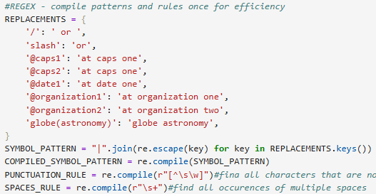
The researcher chose to use class attributes instead of instance variables for the normalisation process to conserve memory – each object will have its own copy of instance variables as compared to one set per class, available to all objects. This means that the normalisation process scales well as the number of input essays grows.
Some members of the sample use the spoken form slash to represent ‘/’, while others use ‘or’. The normalise() method of the EssayEditor class, substitutes these symbols with their spoken forms. This is to ensure that when applied to spoken essays from different speakers, the output is consistent after normalisation, making calculation of the CER and WER more accurate.
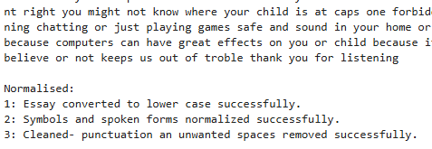
The screenshot above shows the output from the EssayEditor object after its text – the reference essay, has been normalised. The object also prints confirmation of all successfully executed operations – when its show_edit_log() method is invoked.

B.2 Component Testing

- OCR: paddleOCR
- Recognition model: PP-OCRv6_medium_det
- Detection model: PP-OCRv6_medium_rec

- ASR: OpenAi Whisper
- Models: faster-whisper-base, faster-whisper-small, faster-whisper-medium
Test Objectives:
- Obtain the best performing model with respect to inference time, and storage footprint and transcription accuracy
- Determine if whisper’s transcriptions are acceptable to support its inclusion in the AES pipeline

Selecting the best model along with the optimum parameter configuration. A list of six, 2-tuples – (model size, compute_type) parameter configurations were used to select the best model for the system.
Thus, a total of 30 experiments – 5 per each model size, compute_type pair, were carried out. For each pair, transcription was done using beam sizes from 1 to 5 respectively. The results stored as a list of dictionaries are shown in the table below.
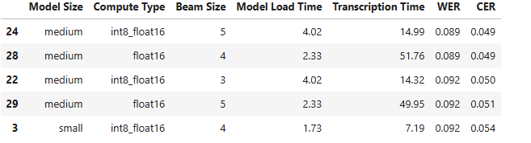
Experiments 24 and 28 achieved the same transcription accuracy. However, they differed noticeably in the time the model took to load. In experiment 24, mixed-precision quantization - int8_float16 was used, along with the beamsize=5. This model took roughly four (4) seconds to transcribe the audio.
The model in experiment 28, with beam size=4 and compute_type=float16, however, took about 50% less time to load but was more than three times slower than the model in experiment 24.
(Questions requiring answers)
Why was the VAD Filter set to True?
Why was the beam size adjusted?
Why were 16 threads alone used?
Why was CUDA fixed?
After the optimum configuration was implemented, the details dictionary was updated to include not only each file’s properties e.g. length and size along with the WER and CER for the transcription but also a “pass” or “fail” evaluation status. These values are assigned in relation to the WER and CER values exceeding the set threshold values of 0.099 and 0.059 respectively. These evaluation labels will be used later, to determine which transcriptions are forwarded to the transformer or human scorer for scoring.
A batch_transcription dictionary stores all individual transcription-detail dictionaries in a list along with WER, CER and evaluation statistics for the batch.
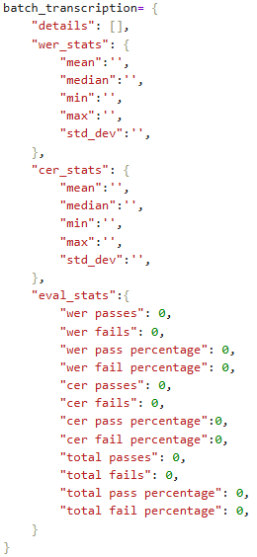
The rationale behind this design decision is to make possible the analysis of transcription statistics per individual transcription and per batch (e.g. a class of 25 students).
Although the WER and CER per batch are stored in the batch_transcription object, their calculation is not performed locally. The global calculate_stats function is invoked to perform these calculations. calculate_stats converts a list of individual transcription statistics to a numpy array and invokes numpy’s statistical functions to obtain an aggregate of the mean, median and so on. The function returns a dictionary with the calculated statistics. The rationale behind this design, is to avoid code redundancy – the OCR component also utilises the calculate_stats function.
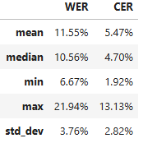
Evaluation of Whisper:
The mean WER, 11.55%, is slightly higher than the acceptable threshold of 9.0%. The max WER however, differs from the min by roughly 15 percentage points – indicating variation in transcription accuracy across the samples. The median WER, 10.56% is slightly above the threshold while the CER, 4.70%, is slightly below the threshold. Whisper transcribed 27 essays. 29.6% were within the acceptable bound and were classified as “pass”, which means that they will be scored by the transformer. The majority, however, more than double the percentage pass, were classified as “fail”, and will be assigned to the human scorer for scoring.
The number of essays classified as “fail”, due to a high WER is more than double that of those classified as “pass”. With respect CER the number of transcriptions that are classified as “pass” is roughly 10% more than those classified as “fail”. The model seems to more consistently get words wrong rather than individual letters or characters. There were 8/27 WER passes, 29.63% and 15/25 CER passes, 55.56%.
The most accurately transcribed essay has a WER of 6.67%, and a CER of less than 2%. Perusal of this essay after normalisation revealed that it is near perfect and that the errors in transcription did not detract from the semantic of the essay. An excerpt is shown below.
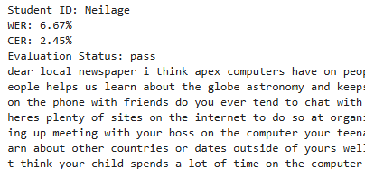
The essay with the median WER percentage has a WER slightly above the acceptable WER threshold, and a CER slightly below the acceptable threshold. 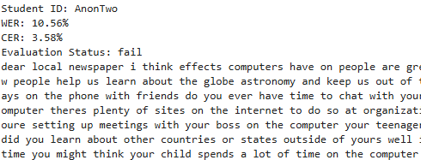
From a visual inspection of the normalised essay, it is apparent that most of the wrongly transcribed words are still decipherable by a human scorer. For example, Whisper transcribed “sea floor spreading” as
. This observation, however, does not motivate an adjustment to the current thresholds as this substitution, though recognisable to a human scorer, is likely to affect the transformer’s interpretation, resulting in an inaccurate score.
The screenshots below are from transcriptions with WER and CER percentages between the min and median and the median and max, respectively.
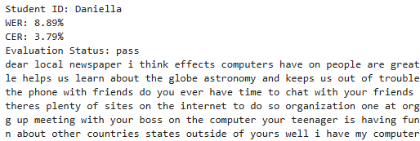
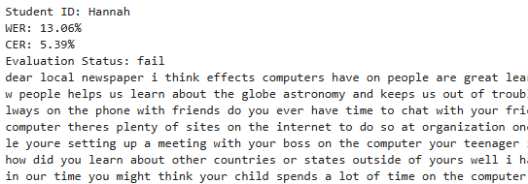
The transcription of Daniella voice is highly accurate with a WER of 8.89% and a CER of 3.79%. The transcription of Hannah although classified as “fail” is still readable and interpretable by a human scorer.
The most inaccurate transcription is still decipherable by a human scorer, as seen in the screenshot below.
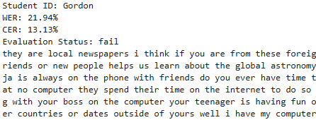
This indicates that the evaluation logic worked as intended, demonstrating sensitivity to transcriptions with high WER percentages, preventing them from moving through the pipeline.
This analysis supports the inclusion of Whisper in the AES pipeline as an assistive technology. However, the high proportion of failed transcriptions justifies the use of evaluation logic to route transcriptions to the appropriate scorer based on their WER and CER

Selection of Essay samples based on variation in writing styles and image composition
Aaliah – warpage, curvature, vignetting, blurry top right edge,
Gordon- use paper without lines, some text overlaps, some characters were cropped, mixed cursive and block style writing
Kaelum – no signs of warpage, however, text is light didn’t seem to press much on pen, last sentence is a bit faint.
Nubia- clear,clean, consistent, text size decreased slightly after the first paragraph so mixed text size
Shemar, very small text, several crossings, writing uniform however some text is illegible. Overall image is underexposed.

Selection of Audio samples-based quality
researcher-assessed recording quality
Daniella- clear, not background noise, words can be easily deciphered, speaker speaks at a reasonable pace
Gordon speaks fast, some words are not easily deciphered the first time they are heard, the audio has some background noise that muffles the speaker’s voice
Katelyn – very difficult to hear as the audio volume is quite low, no evidence of background noise

